**CTF Challenge: Reverse Engineering**

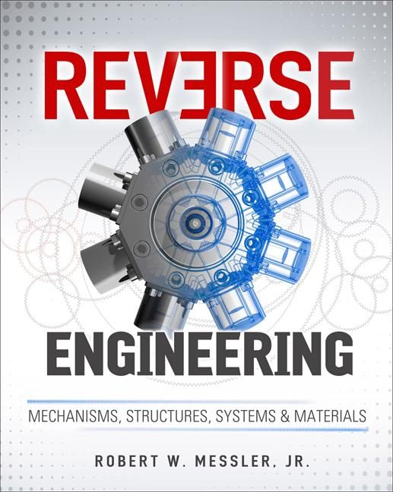

**Why Reverse Engineer?**



There are several reasons why someone might want to reverse engineer a program:

* **Security Analysis:** Identifying vulnerabilities in software to improve its security posture. Hackers might use reverse engineering to exploit these vulnerabilities, while ethical hackers use it to patch them.
* **Understanding Functionality:** Deciphering how a program works, especially when its source code is unavailable. This can be valuable for developers who need to integrate with existing software or for researchers studying malware.
* **Customization:** Modifying a program's behavior for specific needs. However, ethical considerations and copyright laws need to be carefully considered.
* **Learning:** Reverse engineering is a fantastic way to learn about assembly language, compiler inner workings, and software design principles.

**Techniques of Reverse Engineering**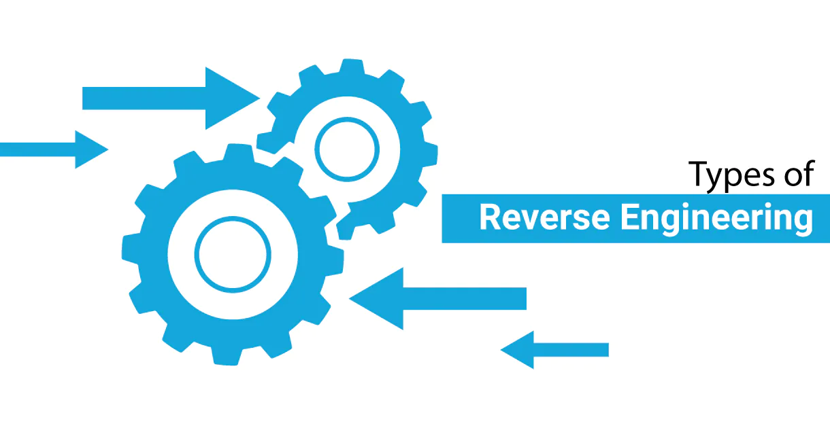

There are various tools and techniques employed in reverse engineering:

* **Disassembly:** Converting machine code instructions into a more human-readable assembly language format. This helps understand the program's basic logic flow.
* **Decompilation:** Attempting to recover the original source code from the binary code. While not always perfect, decompilation can provide a higher-level view of the program's structure.
* **Debugging:** Running the program in a controlled environment and using debugging tools to step through the code line by line, analyzing its behavior at each stage.
* **Static Analysis:** Examining the binary code without actually running the program. This can reveal information about functions, variables, and potential security vulnerabilities in the code itself.
* **Dynamic Analysis:** Running the program in a controlled environment and monitoring its behavior at runtime. This can provide insights into how the program interacts with the operating system and memory, uncovering hidden functionalities.

**Challenges of Reverse Engineering**

Reverse engineering is not for the faint of heart. Here are some challenges you might encounter:

* **Obfuscation:** Programmers may intentionally obfuscate their code to make it harder to understand and reverse engineer.
* **Lack of Documentation:** Sometimes, there's limited or no documentation available for the program, making the analysis process more complex.
* **Anti-Tamper Techniques:** Some software might have built-in mechanisms to detect and prevent reverse engineering attempts.

# **Capture the Flag (CTF) Challenges**

Flag 1: When programmers intentionally make code harder to understand, it's called what?

Answer: Obfuscation

Flag Captured

Flag 2: What tool translates machine code into a more human-readable format? Answer: Disassembly

Flag Captured

Flag 3: What technique involves examining code without running the program?

Answer: Static Analysis

Flag Captured

Flag 4: What process involves stepping through code line by line to analyze its behavior?

Answer: Debugging

Flag Captured

Flag 5: What hidden feature might some software have to prevent reverse engineering?

Answer: Anti-Tamper

Flag Captured